**Tutorial on 2017/05/31**

Q1(Self-test Problem 12)

A basketball team consists of 6 frontcourt and 4 backcourt players. If players are divided into roommates at random, what is the probability that there will be exactly two roommate pairs made up of a backcourt and a frontcourt player?

Answer:

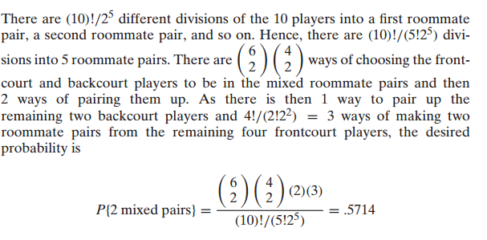

Q2（3.4）

Urn *A* contains 2 white balls and 1 black ball, whereas urn *B* contains 1 white ball and 5 black  
balls. A ball is drawn at random from urn *A* and placed in urn *B*. A ball is then drawn from urn *B*.  
It happens to be white. What is the probability that the ball transferred was white?

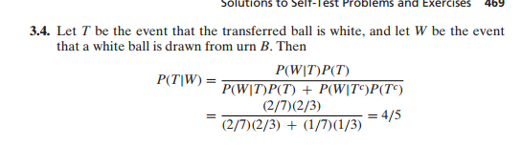

Q3

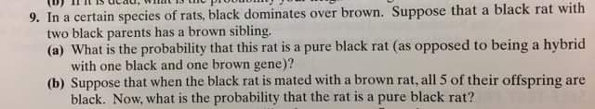

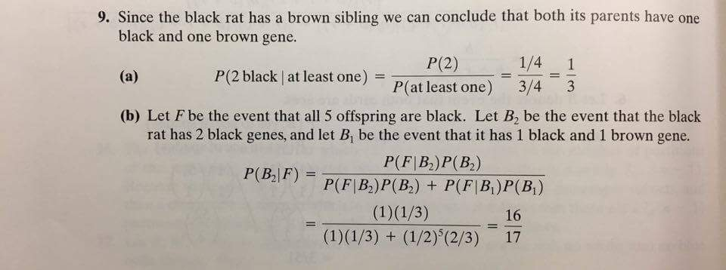

Q4（3.6）

An urn contains *b* black balls and *r* red balls. One of the balls is drawn at random, but when it is  
put back in the urn, *c* additional balls of the same color are put in with it. Now, suppose that we  
draw another ball. Show that the probability that the first ball was black, given that the second ball  
drawn was red, is *b/(b* + *r* + *c)*.

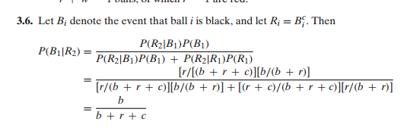

Q5（3.7）

A friend randomly chooses two cards, without replacement, from an ordinary deck of 52 playing  
cards. In each of the following situations, determine the conditional probability that both cards  
are aces.  
**(a)** You ask your friend if one of the cards is the ace of spades, and your friend answers in the  
affirmative.  
**(b)** You ask your friend if the first card selected is an ace, and your friend answers in the affirmative.  
**(c)** You ask your friend if the second card selected is an ace, and your friend answers in the affirmative.  
**(d)** You ask your friend if either of the cards selected is an ace, and your friend answers in  
the affirmative

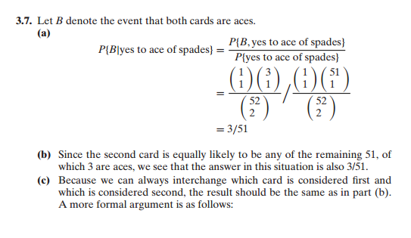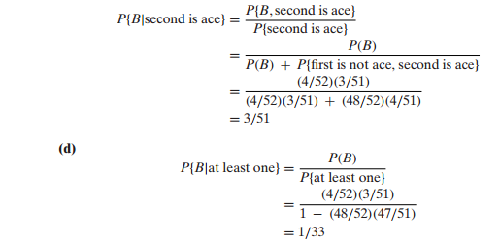

Q6（3.9）

You ask your neighbor to water a sickly plant while you are on vacation. Without water, it will die with probability .8; with water, it will die with probability .15. You are 90 percent certain that  
your neighbor will remember to water the plant.

1. What is the probability that the plant will be alive when you return?  
   **(b)** If the plant is dead upon your return, what is the probability that your neighbor forgot to water it?

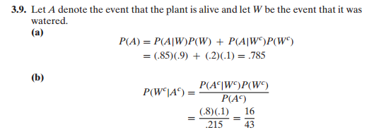

Q7 (3.10)

Six balls are to be randomly chosen from an urn containing 8 red, 10 green, and 12 blue balls.  
**(a)** What is the probability at least one red ball is chosen?  
**(b)** Given that no red balls are chosen, what is the conditional probability that there are exactly 2 green balls among the 6 chosen?

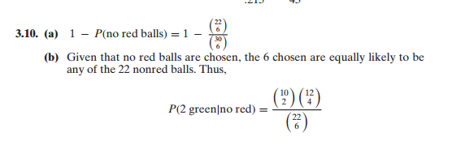

Q8 (3.11)

A type C battery is in working condition with probability *.*7, whereas a type D battery is in working condition with probability *.*4. A battery is randomly chosen from a bin consisting of 8 type C and 6 type D batteries.  
**(a)** What is the probability that the battery works?  
**(b)** Given that the battery does not work, what is the conditional probability that it was a type C battery?